SIMATS ENGINEERING
Department of Computer Science and Engineering
CSA0707 – Computer Networks

ASSIGNMENT 1 – CO1

Make the Data of a Smart Manufacturing Plant Arrive Correctly and On Time
CO1: Apply the functions of the OSI layers in enabling reliable data transmission across networks – uses of networks, network hardware and software, topologies, protocols and standards, ISO/OSI reference model, transmission media, wireless communication, Ethernet configuration, introduction to 5G networks, error detection, error correction and data-link control
Student Name | Y. Naga Giridhar | Register Number | 192572124
Department | B.E-CSE(AI) | Academic Year | 2026-2027
Faculty Name | Dr. Santhiya Lakshmi K | Nature of Assignment | Individual
Duration | 1 Week | Total Marks | 50
Date of Submission |  | Date of Evaluation
GitHub Repository | https://github.com/192572124simats-77/CSA0707-CN

TASK 1 – Size the Traffic Before Choosing Anything
Ans:
1. Traffic of one line and of the plant
Table 1: Traffic per source (payload only, as given)
Source | Calculation | Traffic | Share of line
Robot controllers | 200 B × 8 = 1,600 bit every 2 ms = 0.8 Mbps per robot; 40 × 0.8 | 32.00 Mbps | 20.2 %
Vibration sensors | 50 B × 8 = 400 bit/s per sensor; 600 × 400 = 240,000 bit/s | 0.24 Mbps | 0.2 %
CCTV cameras | 24 × 4 Mbps | 96.00 Mbps | 60.7 %
Office users | 150 users × 2 Mbps × 10 % active | 30.00 Mbps | 19.0 %
One line | 32 + 0.24 + 96 + 30 | 158.24 Mbps | 100 %
Plant, 8 lines | 8 × 158.24 | 1,265.92 Mbps = 1.266 Gbps

If the Ethernet, IP and TCP headers (58 B per command, Task 3) are added, each robot command becomes 258 B, the robot traffic becomes 41.28 Mbps, the line 167.52 Mbps and the plant 1,340.16 Mbps. Headers matter most for the small robot commands.
2. Biggest source and strictest delay
The CCTV cameras send the most data (96 Mbps, 60.7 % of the line). The robot controllers have the strictest delay requirement (10 ms, with a new command every 2 ms), yet they send only 20.2 % of the volume. They are not the same. The largest flow is the most delay-tolerant, and the most delay-critical flow is small. A design based on volume alone would protect the cameras; a correct design must protect the robots from the cameras.
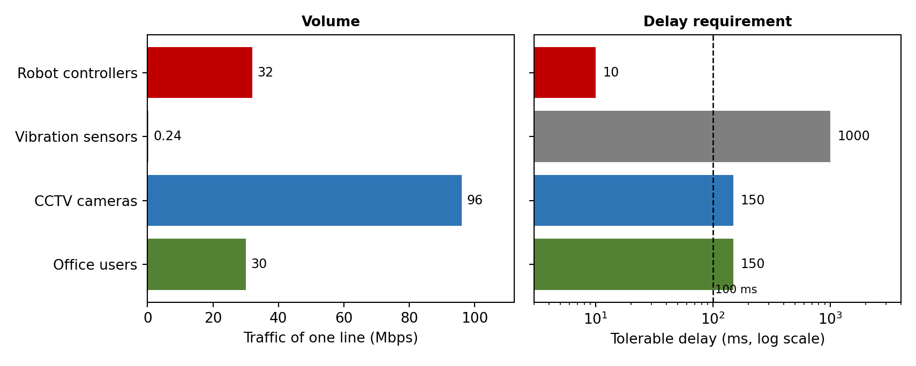
Figure 1: Volume versus delay requirement of one line (delay tolerances other than the robots' 10 ms are engineering estimates)
3. Is a single 1 Gbps uplink enough? Effect of a shared queue
- One line: 158.24 Mbps is 15.8 % of 1 Gbps – enough on average.
- Whole plant: 1,265.92 Mbps is 126.6 % of 1 Gbps. The uplink is not enough; 265.92 Mbps of traffic has no place to go.
- Shared queue: packets wait behind the data in front of them, so the delay of a robot command = queued bits ÷ 1 Gbps. A 1,500-byte video frame costs only 12 µs, but video arrives in bursts. With the plant overloaded, a 1 MB buffer fills in 8 Mbit ÷ 265.92 Mbps = 30.1 ms, after which packets are dropped.
Table 2: Delay a robot command suffers if it queues behind CCTV traffic on a 1 Gbps uplink
Video already queued ahead of the command | Waiting time = bits ÷ 1 Gbps | Against the 10 ms deadline
0.125 MB (1 Mbit) | 1.00 ms | Met
1 MB (8 Mbit) | 8.00 ms | almost the whole budget
4 MB (32 Mbit) | 32.00 ms | missed (3.2 times the deadline)

So robot commands must not share a queue with the CCTV traffic: use a separate VLAN with strict-priority queuing (802.1p) or a separate link, and a faster backbone (10 Gbps, Task 11).
4. Ranking by harm of a 100 ms delay
Rank | Traffic | Why a 100 ms delay hurts (or does not)
1 (most harmful) | Robot controllers | The deadline is 10 ms and a command comes every 2 ms; 100 ms means 50 commands late, 10 times the deadline. A robot arm acts on stale instructions: collision, damaged parts or a safety stop.
2 | Vibration sensors | A reading is sent once per second, so 100 ms is 10 % of the period and harmless for trend analysis. It matters only when the reading triggers a protective shutdown.
3 | CCTV cameras | Live viewing tolerates 100–150 ms; video is buffered. Only remote camera control feels the delay. Loss hurts more than delay.
4 (least harmful) | Office users (ERP, e-mail) | People do not notice 100 ms; e-mail is not time-critical.

5. Alternative: motion-triggered CCTV
CCTV becomes 96 × 0.05 = 4.80 Mbps. The line becomes 32 + 0.24 + 4.80 + 30 = 67.04 Mbps, and the plant 8 × 67.04 = 536.32 Mbps = 53.6 % of 1 Gbps. On average the uplink is no longer the bottleneck (463.68 Mbps spare). Two points remain: (1) if all cameras trigger at once (a plant-wide alarm) the load returns to 1,265.92 Mbps, so priority queuing is still needed; (2) the bottleneck moves from bandwidth to delay – the robots (32 Mbps) become the largest steady flow after the office, and they still need priority. The cost is local storage: continuous recording at 96 Mbps is 12 MB/s, about 1.04 TB per day per line.
Program: Task01/traffic.py – output
Robot controllers 32.00 Mbps 20.2 % of the line
Vibration sensors 0.24 Mbps 0.2 % of the line
CCTV cameras 96.00 Mbps 60.7 % of the line
Office users 30.00 Mbps 19.0 % of the line
ONE LINE 158.24 Mbps = 15.8 % of a 1 Gbps uplink
PLANT (8 lines) 1265.92 Mbps = 1.266 Gbps = 126.6 % of a 1 Gbps uplink

Queueing delay if CCTV shares the queue with the robot commands (illustrative buffer sizes, 1
Gbps):
0.125 MB of video queued ahead of a command -> 1.00 ms
1.000 MB of video queued ahead of a command -> 8.00 ms
4.000 MB of video queued ahead of a command -> 32.00 ms
a 1,500-byte video frame alone costs 12 us; 1 line fills a 1 MB buffer only if the burst
exceeds the uplink
plant overload: 265.92 Mbps excess -> a 1 MB buffer fills in 30.1 ms, then packets are
dropped

Alternative: CCTV sends motion-triggered clips (5 % of the time)
CCTV 4.80 Mbps; line 67.04 Mbps; plant 536.32 Mbps = 53.6 % of 1 Gbps
worst case (all cameras trigger together): plant 1265.92 Mbps again
continuous CCTV storage per line: 12.0 MB/s = 1.04 TB per day
TASK 2 – Count the Domains in the Contractor's Drawing
Ans:
1. Domain counts
A collision domain is the set of ports whose frames can collide; a broadcast domain is the set of devices that receive a broadcast frame. Hubs repeat signals to all ports (one collision domain); every switch port and every router interface is its own collision domain; only routers (or VLANs) split broadcast domains.
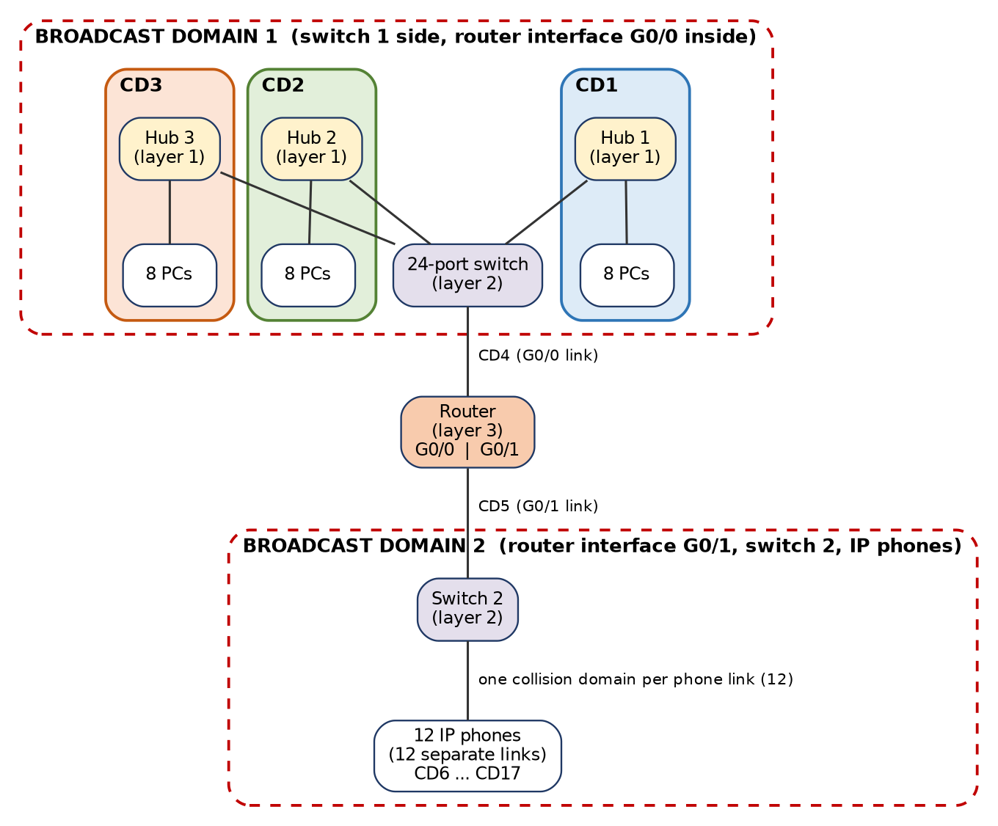
Figure 2: Contractor's drawing with collision domains (CD1–CD17) and broadcast domains marked
Table 3: How the domains are counted
Collision domain | What it contains | Count
CD1, CD2, CD3 | Each hub with its 8 PCs and the switch port it is plugged into (shared medium) | 3
CD4 | Link between the 24-port switch and router G0/0 (point-to-point) | 1
CD5 | Link between router G0/1 and the second switch | 1
CD6 – CD17 | One link for each of the 12 IP phones to the second switch | 12
Total collision domains |  | 17

Broadcast domains = 2. Domain 1: the 24 PCs, the hubs, switch 1 and router interface G0/0. Domain 2: router interface G0/1, switch 2 and the 12 IP phones. The router stops broadcasts between them (assuming no VLANs).
2. OSI layer of each device and why a hub cannot stop collisions
Device | OSI layer | Reason
Hub | Layer 1 – Physical | Only regenerates and repeats electrical signals; it does not read addresses.
Switch | Layer 2 – Data link | Reads the destination MAC address, learns addresses and forwards the frame only to the right port.
Router | Layer 3 – Network | Reads the IP address and chooses the path between networks; separates broadcast domains.
PCs, IP phones | Layers 1–7 (end systems) | Run the whole protocol stack up to the application.

A hub has no memory and no knowledge of addresses: a signal arriving on one port is sent out on all other ports at once. All devices on the hub therefore share one wire electrically, and two stations that transmit at the same time collide. The hub can neither buffer a frame nor choose a port, so collisions are not stopped; CSMA/CD is needed and the 8 PCs share the bandwidth (for example one 100 Mbps).
3. Point-to-point and multipoint connections
- Point-to-point: hub–switch, switch–router G0/0, router G0/1–switch 2, and each IP phone–switch 2 link (two ends only, dedicated, full duplex possible).
- Multipoint (shared): each hub with its 8 PCs. The cables are physically a star, but electrically the 8 PCs and the switch port share one medium, so it behaves as a multipoint (bus-like) segment.
4. Standards and why standard-compliant equipment must be bought
Table 4: Standards and bodies
Technology | Standard | Body | What it defines
Ethernet | IEEE 802.3 | IEEE (LAN/MAN Standards Committee) | Frame format, MAC (CSMA/CD), cable and physical layers
Wi-Fi | IEEE 802.11 | IEEE (Wi-Fi Alliance certifies products) | Wireless LAN MAC and physical layers
IPv4 | RFC 791 | IETF | Internet Protocol: addressing and packet format
OSI model | ISO 7498 (ISO/IEC 7498-1) | ISO (also ITU-T X.200) | Seven-layer reference model
5G | Releases 15 and later; IMT-2020 | 3GPP (specifications) and ITU (requirements) | Radio access, core network and service types (eMBB, URLLC, mMTC)

Standard-compliant equipment is bought because it is interoperable (devices from different vendors work together), avoids vendor lock-in and lets prices compete, is tested and certified, can be upgraded step by step as the plant grows from 1 line to 5 plants, and gives engineers one documented behaviour to troubleshoot. Proprietary equipment can strand the plant if a vendor stops support.
5. Alternative: three unmanaged switches instead of the hubs
Every PC now has its own switch port: 24 PC links + 3 uplinks to the 24-port switch + 1 + 1 + 12 phone links = 41 collision domains (was 17). Broadcast domains stay at 2.
What this change fixes | What it does not fix
Collisions disappear: each link is full duplex, so CSMA/CD is no longer needed. Each PC gets dedicated bandwidth (not 1/8 of a shared 100 Mbps). Switches learn MAC addresses, so unicast frames are no longer seen by every PC. | The broadcast domain is still one flat network of all the PCs (broadcast and multicast traffic still reaches every port). There are no VLANs, no QoS priority, no port security, no monitoring or spanning-tree control (unmanaged), and the single link to the router is still a bottleneck. Voice and data are not separated.
Program: Task02/domains.py – output
Contractor drawing (3 hubs) collision domains = 17, broadcast domains = 2
Colleague proposal (3 unmanaged switches) collision domains = 41, broadcast domains = 2
TASK 3 – Read a Captured Frame Layer by Layer
Ans:
1. Layer and PDU of each line
Capture line | OSI layer | Protocol | PDU | Size / key fields
Ethernet II | 2 – Data link | Ethernet | Frame | 14 B header (6 + 6 + 2) + 4 B FCS; Type 0x0800 = IPv4
IPv4 | 3 – Network | IP | Packet | 20 B header; TTL 61; Protocol 6 = TCP
TCP | 4 – Transport | TCP | Segment | 20 B header; port 51522 → 502 (Modbus/TCP); Seq 1201, Ack 88
Data | 7 – Application | Modbus | Data (message) | 12 B write-register command

2. Routers crossed
Every router subtracts 1 from the TTL. 64 − 61 = 3 routers were crossed.
3. Bytes on the wire and overhead
Frame | Ethernet header | IP | TCP | Data | FCS | Total | Overhead
Modbus command | 14 | 20 | 20 | 12 | 4 | 70 B | 58 B = 82.86 %
1,400-byte camera packet (assumed 1,400 B of data) | 14 | 20 | 20 | 1,400 | 4 | 1,458 B | 58 B = 3.98 %

Meaning: the same 58 bytes of headers are almost the entire frame for a small command (83 %) but a negligible part of a camera packet (4 %). Small commands are therefore very inefficient: 40 robots sending every 2 ms need 41.28 Mbps on the wire instead of 32 Mbps (Task 1). For robot traffic, the cost is paid to gain reliability and routing; where possible commands should be kept small and sent over short paths or by lean industrial protocols.
4. Which layer is responsible
Fault | Layer | What happens
(a) MAC address is wrong | 2 – Data link | The receiving NIC (or switch) finds that the destination MAC does not match and discards the frame.
(b) TTL reaches 0 | 3 – Network | The router discards the packet and sends an ICMP "Time Exceeded" message to the source (this is how traceroute works).
(c) Destination port is closed | 4 – Transport | The receiving TCP replies with a reset (RST); the connection fails.

5. TCP/IP model mapped onto the seven OSI layers
TCP/IP layer | OSI layers | Examples
Application | 7 Application, 6 Presentation, 5 Session | Modbus, HTTP, SNMP
Transport | 4 Transport | TCP, UDP
Internet | 3 Network | IP, ICMP
Network access (link) | 2 Data link, 1 Physical | Ethernet, Wi-Fi, 5G radio

6. Complete the Code – Task03/layers.py
TODO 1 was completed inside the loop: the header "[tag|" is added, the trailer is "|FCS]" for the data-link layer and "]" for the others, and the new size is printed.
"""How data is wrapped by each layer at the sender and unwrapped at the receiver."""
LAYERS = [("Application", "HTTP"), ("Transport", "TCP"), ("Network", "IP"),
("Data link", "ETH")]

def send(message):
pdu = message
for layer, tag in LAYERS:
# TODO 1 (completed): wrap pdu with this layer's header "[tag|" and, for the data
link
# layer only, also a trailer "|FCS]"; for other layers close with "]".
head = "[" + tag + "|"
tail = "|FCS]" if tag == "ETH" else "]"
pdu = head + pdu + tail
print(f"{layer} adds {tag} -> {len(pdu)} bytes")
return pdu

def receive(frame):
pdu = frame
for layer, tag in reversed(LAYERS):
head = "[" + tag + "|"
tail = "|FCS]" if tag == "ETH" else "]"
assert pdu.startswith(head) and pdu.endswith(tail), f"{layer}: bad header"
pdu = pdu[len(head):-len(tail)]
return pdu

frame = send("GET /results")
print("on the wire:", frame)
print("delivered :", receive(frame))
print(f"overhead : {len(frame) - len('GET /results')} bytes for 12 bytes of data")
Output:
Application adds HTTP -> 19 bytes
Transport adds TCP -> 25 bytes
Network adds IP -> 30 bytes
Data link adds ETH -> 40 bytes
on the wire: [ETH|[IP|[TCP|[HTTP|GET /results]]]|FCS]
delivered : GET /results
overhead : 28 bytes for 12 bytes of data
Message changed to 1,400 bytes – Task03/layers_1400.py output
Application adds HTTP -> 1407 bytes
Transport adds TCP -> 1413 bytes
Network adds IP -> 1418 bytes
Data link adds ETH -> 1428 bytes
delivered correctly: True
overhead : 28 bytes for 1400 bytes of data = 1.96 % of the frame
(for the 12-byte message: 28 bytes of 40 = 70.00 %)
The overhead is the same 28 bytes in both runs, but it is 70 % of a 12-byte frame and only 1.96 % of a 1,400-byte frame. This agrees with the 82.9 % and 4.0 % found above for the real headers.
7. Alternative: raw Ethernet frame (EtherType 0x8892)
Removing IP (20 B) and TCP (20 B) removes 40 bytes, but an Ethernet frame must be at least 64 bytes (46 bytes of payload), so the 12-byte command is padded to 64 B: 14 + 12 + 4 = 30 B → 64 B. The saving is therefore only 70 − 64 = 6 bytes per command.
100 Mbps link | With IP + TCP (70 B) | Raw Ethernet (64 B) | Commands per second freed
Frame only | 178,571 / s | 195,312 / s | 16,741 / s (+9.4 %)
With preamble and inter-frame gap (+20 B) | 138,889 / s | 148,810 / s | 9,921 / s (+7.1 %)

What the plant loses by giving up IP: routing between subnets and to the head office 400 km away (raw frames cannot cross a router and stay inside one broadcast domain); IP addressing and TTL; TCP's acknowledgements, retransmission, ordering and flow control (the application must handle loss itself, for example by cyclic exchange); port numbers for multiplexing; firewalls and access lists at layer 3; and standard tools such as ping and traceroute. The gain is smaller than expected (6 B, about 9 %), so raw Ethernet is justified only for the closed real-time robot segment, not plant-wide.
Program: Task03/overhead_calc.py – output
Modbus command data 12 B total 70 B overhead 58 B = 82.86 %
Camera packet data 1400 B total 1458 B overhead 58 B = 3.98 %
Task-1 robot command 200 B -> 258 B on the wire, overhead 22.48 %
40 robots x 500 cmd/s x 258 B -> 41.28 Mbps with headers (32.00 Mbps payload only)
raw Ethernet frame: 14+12+4 = 30 B -> padded to 64 B ; saved 6 B per command
100 Mbps, frame only : IP/TCP 178571 cmd/s, raw 195312 cmd/s, frees
16741 cmd/s (9.4 %)
100 Mbps, with preamble+IFG (20 B) : IP/TCP 138889 cmd/s, raw 148810 cmd/s, frees
9921 cmd/s (7.1 %)
TASK 4 – Choose a Medium for Each Run (There Is a Trap)
Ans:
1. Medium for each run
Run | Distance | Medium chosen | Deciding reason
(a) Robot cell by the welders | 85 m | Cat6A S/FTP (shielded, bonded to earth), industrial M12/RJ45; multimode fibre if noise tests fail | 85 m is inside the 100 m copper limit. Welding produces strong electrical noise; foil and braid shielding keeps the SNR high (see Shannon below). Fibre is immune to noise, but costs more and the robots' ports are copper.
(b) Office floor to shop floor | 140 m | Multimode fibre (OM3/OM4) | 140 m is beyond the 100 m limit of twisted pair. Fibre also isolates the office from shop-floor electrical noise and earth differences.
(c) Shop floor to data centre | 550 m | Single-mode fibre (10GBASE-LR) | Copper is impossible. Multimode would reach 550 m only at 1 Gbps (1000BASE-SX); the plant needs 1.27 Gbps, so 10 Gbps is required, and 10GBASE-SR multimode reaches only 300–400 m. Single-mode also leaves room for 5 plants.
(d) Plant to head office | 400 km | Leased line (carrier fibre, Ethernet or MPLS service, with SLA) | No private cable over 400 km. A carrier link gives guaranteed rate, repair times and a second path; a single broadband line has no guarantee.

2. The trap: which run cannot use copper Ethernet
Twisted-pair Ethernet (Cat6/Cat6A) works only up to 100 m per channel. Run (c) 550 m and run (d) 400 km can never use copper (even repeaters are not practical over 400 km). The real trap is run (b): 140 m looks short and a careless choice would be Cat6, but it exceeds the 100 m limit – copper could be saved only by adding an intermediate switch, which is a new failure point, so fibre is the better choice. Another trap is run (c): multimode fibre looks right for 550 m, but only at 1 Gbps.
3. Shannon capacity and what it means for the robot cell
C = B × log₂(1 + SNR), with SNR as a ratio: SNR = 10^(dB/10).
Case | SNR ratio | log₂(1 + SNR) | Capacity
250 MHz cable, SNR 40 dB | 10,000 | 13.288 | 3,321.96 Mbps
Same cable near the welders, SNR 15 dB | 31.62 | 5.027 | 1,256.95 Mbps

The noise near the welders cuts the theoretical capacity by 62.2 % (to 37.8 % of the clean value). It is still above 1 Gbps on paper, but the low SNR means more bit errors, failed CRCs and retransmissions, and a very small margin: a little more noise breaks the link. Since the robot commands need a timely and reliable link, the cell must be wired with shielded cable (or fibre) to keep the SNR high; an unshielded cable should not be used there.
4. Why the measured speed is always below the Shannon limit
Shannon's value is an upper limit that needs ideal coding and no overhead. Real links are slower because: (1) practical modulation and coding are not ideal and need a safety margin; (2) the real SNR is lower (crosstalk, attenuation with length, interference); (3) headers, preamble, inter-frame gaps and line-coding overhead use part of the bit rate; (4) errors cause retransmission; and (5) the measured "speed" is usually goodput (useful data only).
5. Complete the Code – Task04/media.py
"""Nyquist and Shannon limits for the transmission media proposed for a campus."""
import math

def nyquist(bandwidth_hz, levels):
# TODO 1 (completed): Nyquist maximum bit rate for a noiseless channel = 2 x bandwidth x
log2(levels)
return 2 * bandwidth_hz * math.log2(levels)

def shannon(bandwidth_hz, snr_db):
# TODO 2 (completed): convert SNR from decibels to a ratio, then capacity = B x log2(1 +
SNR)
snr = 10 ** (snr_db / 10)
return bandwidth_hz * math.log2(1 + snr)

media = [("Telephone line", 3_100, 30), ("Cat6 pair", 250e6, 40),
("Wi-Fi 6 channel", 160e6, 25)]
for name, bw, snr in media:
print(f"{name:<16} Shannon limit {shannon(bw, snr) / 1e6:10.2f} Mbps")
print(f"Nyquist, 3,100 Hz with 4 levels: {nyquist(3_100, 4) / 1e3:.1f} kbps")
Output :
Telephone line Shannon limit 0.03 Mbps
Cat6 pair Shannon limit 3321.96 Mbps
Wi-Fi 6 channel Shannon limit 1329.50 Mbps
Nyquist, 3,100 Hz with 4 levels: 12.4 kbps
SNR for 56 kbps on a 3,100 Hz line: 1 + SNR = 2^(56,000 / 3,100) = 2^18.06, so SNR ≈ 274,132, which is 54.4 dB. A real telephone line has about 30–35 dB (30 dB gives only 30.9 kbps), so 56 kbps is not realistic on an analogue line. 56 kbps modems worked only because the ISP end was digital, which removes one analogue section and its noise.
Program: Task04/media_extra.py – output
SNR needed for 56 kbps on 3,100 Hz: ratio 274,132 = 54.38 dB
250 MHz cable, SNR 40 dB: 3321.96 Mbps
250 MHz cable, SNR 15 dB: 1256.95 Mbps (37.8 % of the 40 dB value, a drop of 62.2 %)
Wi-Fi 6, 160 MHz, SNR 15 dB: 804.45 Mbps (SNR 25 dB gave 1329.50 Mbps)
robot traffic of one line = 32 Mbps = 4.0 % of that Shannon limit
6. Alternative: Wi-Fi 6 in the robot cell
At SNR 15 dB on 160 MHz: C = 160 × 10⁶ × log₂(32.62) = 804.45 Mbps (it was 1,329.50 Mbps at 25 dB). The 32 Mbps of robot traffic of a line is only 4 % of that, so capacity is not the problem; timing is. Wi-Fi shares the air with other devices (CSMA/CA contention), adapts its data rate and retransmits when noise rises, so delay and jitter are not guaranteed, and welding noise makes this worse. A 10 ms deadline for every command cannot be guaranteed. Decision: a wireless link is not acceptable for the fixed robot commands; use shielded cable. Wi-Fi 6 is acceptable for non-critical devices in the same area.
TASK 5 – Wi-Fi 6 or 5G for Moving Equipment?
Ans:
1. Hand-overs and unreachable time
Trip time = 1,200 m ÷ 2 m/s = 600 s. Hand-overs = route ÷ cell size (cell crossings).
 | Wi-Fi 6 (150 ms) | Wi-Fi 6 + 802.11r (assumed 50 ms) | Private 5G (20 ms)
Cell size | 30 m | 30 m | 300 m
Hand-overs per trip | 1,200 ÷ 30 = 40 | 40 | 1,200 ÷ 300 = 4
Time between hand-overs | 15 s | 15 s | 150 s
AGV unreachable per trip | 40 × 150 ms = 6.0 s (1.0 % of the trip) | 40 × 50 ms = 2.0 s (0.33 %) | 4 × 20 ms = 0.08 s (0.013 %)
Distance travelled blind per hand-over | 0.30 m | 0.10 m | 0.04 m
10 ms deadlines missed per hand-over | 15 | 5 | 2

(If the trip starts and ends inside a cell, the counts are one fewer: 39 and 3; the conclusion does not change.) Wi-Fi leaves an AGV unreachable 75 times longer than 5G (6.0 s against 0.08 s) and each Wi-Fi gap is 15 times the command deadline.
2. 5G service type for each traffic
Traffic | Service type | Reason
AGV commands | URLLC (ultra-reliable low-latency) | Small messages with a 10 ms deadline that must not be lost.
CCTV cameras | eMBB (enhanced mobile broadband) | High data rate (4 Mbps each, 96 Mbps per line); delay is not critical.
Sensors | mMTC (massive machine-type) | Hundreds of devices, tiny and infrequent messages (50 B/s), low power.

3. Where Bluetooth, Zigbee and LoRa are better
Technology | Strength | Better than Wi-Fi / 5G for
Bluetooth (BLE) | Very low power, 10–50 m, cheap | Tool and asset tags, wearable safety badges, technicians' handheld accessories, short links to a nearby gateway.
Zigbee | Low-power mesh, 10–100 m, years on a battery | Clusters of battery-powered temperature or lighting/HVAC sensors inside a hall where a mesh can relay data.
LoRa / LoRaWAN | Range of kilometres, few kbps, years on a battery | Slow-changing data from far or outdoor points: yard, tank levels, remote buildings, utility meters.

They win where data is small, delay is unimportant and battery life and cost matter. They are not suitable for AGV commands or video.
4. Can Wi-Fi 6 with fast roaming (802.11r) meet the deadline?
802.11r pre-computes keys so a hand-over drops from 150 ms to roughly 50 ms (assumed). That is still 5 times the 10 ms deadline: every one of the 40 hand-overs causes about 5 missed commands (200 per trip, 2.0 s unreachable). It cannot meet the deadline during a hand-over. What remains risky: (1) the gap itself; (2) contention and retransmissions with the other 1,500 devices on the shared channel, so delay varies; (3) interference and welding noise; (4) "sticky" AGVs that hold on to a weak AP, and ping-pong between APs; (5) AGV radios that do not support 802.11r. Wi-Fi 6 may be used if the AGV can safely stop and buffer commands, but not for "never miss a command".
5. Alternative: LoRaWAN for the sensors
One sensor needs 50 B/s = 400 bit/s. 600 sensors need 240 kbit/s, which is 48 times the 5 kbps of one gateway. A gateway can carry only 5,000 ÷ 400 = 12.5 sensors at that rate (and fewer in practice, because LoRaWAN uses ALOHA access with about 18 % efficiency). So the 50 B/s vibration sensors do not fit LoRa.
Reporting rate | Bit rate per sensor | Sensors per gateway (ideal) | With 18 % efficiency
50 B every 1 s (as given) | 400 bps | 12.5 | 2
50 B every 10 s | 40 bps | 125 | 22
50 B every 60 s | 6.7 bps | 750 | 135

Decision: the vibration sensors (continuous, 1 reading per second, possibly needed for protection) stay on Wi-Fi / 5G mMTC. Only slow temperature sensors that can report about once a minute move to LoRaWAN (about 135 per gateway), which saves Wi-Fi capacity and battery.
Program: Task05/mobility.py – output
trip time = 1200 m / 2.0 m/s = 600 s
Wi-Fi (30 m APs, 150 ms hand-over) hand-overs 40 (cell crossings; 39 if the trip starts and ends
inside a cell), unreachable 6.000 s per trip = 1.000 % of the trip; AGV moves 0.30 m blind per
hand-over; 10 ms deadlines missed per hand-over 15.0
Private 5G (300 m cells, 20 ms hand-over) hand-overs 4 (cell crossings; 3 if the trip starts and ends
inside a cell), unreachable 0.080 s per trip = 0.013 % of the trip; AGV moves 0.04 m blind per
hand-over; 10 ms deadlines missed per hand-over 2.0
Wi-Fi 6 + 802.11r (assumed 50 ms) hand-overs 40 (cell crossings; 39 if the trip starts and ends
inside a cell), unreachable 2.000 s per trip = 0.333 % of the trip; AGV moves 0.10 m blind per
hand-over; 10 ms deadlines missed per hand-over 5.0

LoRa gateway capacity
one sensor = 50 B/s = 400 bps; 600 sensors = 240 kbps; gateway ~5 kbps -> demand is 48 times the capacity
sensors a 5 kbps gateway can carry at 50 B/s: 12.5
1 reading per 10 s: 40.0 bps per sensor -> 125 sensors per gateway (ideal), ~ 22 with ALOHA
efficiency of 18 %
1 reading per minute: 6.7 bps per sensor -> 750 sensors per gateway (ideal), ~ 135 with ALOHA
efficiency of 18 %
TASK 6 – Interpret an Ethernet Port Report
Ans:
1. Meaning of the counters
- Late collision (412): a collision detected after the first 512 bits (64 bytes) of a frame have been sent. In a correct half-duplex network all collisions happen in that window, so a late collision means the two ends disagree about who may transmit, or the cable is too long. It is not normal.
- CRC error (1,907): a frame arrived but its FCS does not match, so the bits were damaged (by noise, or because a transmission was cut off by a collision). The frame is discarded.
- Combination: late collisions together with many CRC errors and rx_errors are the classic signature of a duplex mismatch: one end is half duplex (listens before transmitting and detects collisions), the other end is full duplex (sends whenever it wants and ignores carrier and collisions). The half-duplex end sees late collisions and damaged frames; the retransmissions make the PC slow.
2. Likely cause and the exact configuration change
The PC is forced to 100 Mb/s half duplex with auto-negotiation off, while the gigabit switch port is on auto (and has settled on full duplex). Note: by the standard, a port on auto that meets a partner with auto-negotiation off can detect only the speed, and then assumes half duplex; a mismatch therefore appears when the switch end is full duplex (configured or defaulted by its firmware). The switch port should be checked as well (show interfaces status). In either case, a gigabit link must negotiate: 1000BASE-T requires auto-negotiation.
Fix on Linux (Task06/linux_ethtool_fix.sh):
ethtool eth0 # before: 100Mb/s, Half, Auto-negotiation: off
sudo ethtool -s eth0 autoneg on # negotiate 1000 Mb/s full duplex with the switch
ethtool eth0 # after: 1000Mb/s, Full, Auto-negotiation: on
ethtool -S eth0 | grep -Ei "collision|crc|error" # the counters must stop increasing
Fix on Windows: Device Manager → network adapter → Properties → Advanced → "Speed & Duplex" → Auto Negotiation (or PowerShell: Set-NetAdapterAdvancedProperty -Name "Ethernet" -DisplayName "Speed & Duplex" -DisplayValue "Auto Negotiation"). On the switch (Cisco): interface Gi0/5, speed auto, duplex auto. After the change, clear the counters and verify that late_collisions and crc_errors no longer rise. (If a fixed setting must be used, both ends must be set to the same speed and full duplex.)
3. The two MAC addresses
Address | First byte | Meaning
01:00:5e:0a:01:02 | 0000 0001: I/G bit = 1 | Group (multicast) address. The prefix 01:00:5e is reserved for IPv4 multicast; the last 23 bits (0a:01:02) carry the group, 224.10.1.2 (and 31 other groups share it).
3c:52:82:4e:11:07 | 0011 1100: I/G = 0, U/L = 0 | A single device (unicast), globally assigned. The first three bytes 3c:52:82 are the OUI (Organizationally Unique Identifier) that identifies the manufacturer of the network card; it can be looked up in the IEEE registry. The last three bytes (4e:11:07) are the serial number given by the manufacturer.

4. Jumbo frames for the CCTV storage server
Jumbo frames (MTU 9,000) would help, moderately. Per frame the headers cost 58 B: efficiency rises from 1,460 / 1,518 = 96.18 % to 8,960 / 9,018 = 99.36 %, and the number of frames per megabyte falls from 685 to 112, which cuts the interrupts and CPU load of the storage server (the real gain). The bandwidth gain is only about 3 %.
What must also change: (1) every device in the path must use the same MTU – the server NIC, switch ports (for example system mtu jumbo 9000), and every VLAN/router interface on the path – or frames are dropped or fragmented; (2) the cameras must send large frames (cameras sending 1,400-byte packets gain nothing unless the storage path aggregates); (3) jumbo frames must be kept on the storage VLAN only: a 9,000-byte frame takes 0.72 ms at 100 Mbps (0.072 ms at 1 Gbps) to serialise and would block robot commands in a shared queue (Task 1).
Program: Task06/mac_check.py – output
01:00:5e:0a:01:02: first byte 00000001 I/G bit = 1 (group / multicast); U/L bit = 0 (universally
administered); OUI = 01:00:5e
3c:52:82:4e:11:07: first byte 00111100 I/G bit = 0 (single device / unicast); U/L bit = 0 (universally
administered); OUI = 3c:52:82
multicast MAC 01:00:5e:0a:01:02 carries the low 23 bits of an IPv4 group address: x.10.1.2 (224.10.1.2,
225.10.1.2 ... 239.138.1.2 share it)

Frame efficiency, TCP payload / bytes on the wire
MTU 1500: payload 1460 B, wire 1518 B, efficiency 96.18 %, frames needed per MB: 685
MTU 9000: payload 8960 B, wire 9018 B, efficiency 99.36 %, frames needed per MB: 112
serialisation delay of one 9,000-byte frame at 100 Mbps = 0.721 ms (a 1,500-byte frame: 0.121 ms)
serialisation delay of one 9,000-byte frame at 1000 Mbps = 0.072 ms (a 1,500-byte frame: 0.012 ms)
5. Alternative: ring of industrial switches versus star
Single cable cut | Ring with fast recovery (for example MRP / RSTP) | Star of switches
Recovery time | Automatic. MRP (IEC 62439-2) recovers in about 200 ms (profiles of 30 ms or 10 ms exist); RSTP in a ring takes from several hundred ms to a few seconds. (Typical values.) | None – no alternative path. The link is down until the cable is repaired (minutes to hours).
Devices that lose connection | Every device whose path crossed the cut loses connection only during the recovery time; afterwards all devices are reachable via the other direction of the ring. | Leaf cable: only that device. Uplink to an access switch: all devices on that switch until repair.
Effect on 10 ms robots | A 200 ms outage is 100 missed commands, so robots still need a local safe-stop; use HSR/PRP (zero recovery) where this is not acceptable. | Complete loss for the affected robots.
Cost | Ring cabling is cheap; switches must support the ring protocol. | Simpler, but more cable to the centre; the central switch is a single point of failure.
TASK 7 – Will the Receiver Notice the Error?
Ans:
1. CRC of 1101011011 with generator 1011 (modulo-2 division)
The generator has 4 bits, so 3 zeros are appended: 1101011011000. At each step, if the leading bit is 1, XOR the generator (1011) at that position (no carries); if it is 0, move on.
1101011011000
⊕ 1011 leading 1 at bit 0
-------------
0110011011000
⊕ 1011 bit 1
0011111011000
⊕ 1011 bit 2
0001001011000
⊕ 1011 bit 3
0000010011000 (bit 4 is 0: no XOR)
⊕ 1011 bit 5
0000000101000 (bit 6 is 0: no XOR)
⊕ 1011 bit 7
0000000000100 remainder = last 3 bits = 100
CRC = 100, so the transmitted frame is 1101011011100 (the same as the program output).
2. Is 1101011011101 accepted?
The same division of the received frame leaves the remainder 001 (≠ 000), so the frame is rejected. The received frame differs from the correct frame 1101011011100 in the last bit: a 1-bit error is always detected.
3. Burst errors and an undetectable pattern
- Longest burst certainly detected: 3 bits. A CRC with r = 3 check bits detects every burst of length ≤ r (the program confirmed all bursts of length 1, 2 and 3 at every position of the 13-bit frame).
- A pattern it cannot detect: any error pattern that is a multiple of the generator. The simplest is the generator itself, 1011, placed anywhere in the frame (for example 0010110000000): the corrupted frame still divides evenly, so the receiver accepts it. Another is two bit errors exactly 7 positions apart (x⁷ + 1 is divisible by x³ + x + 1): the program found (0,7), (1,8), (2,9), (3,10), (4,11), (5,12) in the 13-bit frame.
4. Two-dimensional parity
Chosen 4 × 4 block with even parity (the last column is the row parity; the last row is the column parity):
 | c1 | c2 | c3 | c4 | row parity
r1 | 1 | 0 | 1 | 1 | 1
r2 | 0 | 1 | 1 | 0 | 0
r3 | 1 | 1 | 0 | 0 | 0
r4 | 0 | 1 | 0 | 1 | 0
column parity | 0 | 1 | 0 | 0 | 1

A 4-bit error it misses: flip the four corners of a rectangle – bits (r1,c2), (r1,c4), (r3,c2), (r3,c4). Rows r1 and r3 each change twice and columns c2 and c4 each change twice, so every row and column parity stays correct and the error is not detected (block r1 becomes 1110, r3 becomes 1001; confirmed by the program).
5. Internet checksum of 4500, 0073, 0000, 4000
Sum: 4500 + 0073 = 4573; + 0000 = 4573; + 4000 = 8573 (no carry to add). One's complement of 8573 = 7A8C. Check: 8573 + 7A8C = FFFF, so the receiver's sum is all ones and the data is accepted. Internet checksum = 7A8C.
6. Complete the Code – Task07/crc.py
"""CRC error detection for frames sent between two switches."""

def mod2_div(dividend, divisor):
"""Return the remainder of modulo-2 (XOR) division of two bit strings."""
rem = list(dividend)
for i in range(len(dividend) - len(divisor) + 1):
# TODO 1 (completed): if the current leading bit rem[i] is 1, XOR the divisor into
rem
# starting at position i
if rem[i] == "1":
for j in range(len(divisor)):
rem[i + j] = "0" if rem[i + j] == divisor[j] else "1"
return "".join(rem[-(len(divisor) - 1):])

def encode(data, gen):
crc = mod2_div(data + "0" * (len(gen) - 1), gen)
return data + crc

def check(frame, gen):
return set(mod2_div(frame, gen)) == {"0"}

GEN = "1011" # x^3 + x + 1
frame = encode("1101011011", GEN)
print("transmitted:", frame)
print("no error :", check(frame, GEN))
bad = frame[:4] + ("1" if frame[4] == "0" else "0") + frame[5:]
print("1-bit error:", check(bad, GEN))
burst = frame[:2] + "".join("1" if b == "0" else "0" for b in frame[2:5]) + frame[5:]
print("3-bit burst:", check(burst, GEN))
Output :
transmitted: 1101011011100
no error : True
1-bit error: False
3-bit burst: False
Program: Task07/crc_extra.py – evidence for sections 1 to 5 and the table below
(a) CRC of 1101011011 with generator 1011
step at bit 0: 1101011011000 XOR 1011 -> 0110011011000
step at bit 1: 0110011011000 XOR 1011 -> 0011111011000
step at bit 2: 0011111011000 XOR 1011 -> 0001001011000
step at bit 3: 0001001011000 XOR 1011 -> 0000010011000
step at bit 5: 0000010011000 XOR 1011 -> 0000000101000
step at bit 7: 0000000101000 XOR 1011 -> 0000000000100
CRC = 100 transmitted frame = 1101011011100
step at bit 0: 1101011011101 XOR 1011 -> 0110011011101
step at bit 1: 0110011011101 XOR 1011 -> 0011111011101
step at bit 2: 0011111011101 XOR 1011 -> 0001001011101
step at bit 3: 0001001011101 XOR 1011 -> 0000010011101
step at bit 5: 0000010011101 XOR 1011 -> 0000000101101
step at bit 7: 0000000101101 XOR 1011 -> 0000000000001
(b) received 1101011011101: remainder 001 -> REJECTED

(c) burst errors and undetected patterns
all bursts of length 1, 2 and 3 detected: True
error pattern equal to the generator (1011) placed at bits 2-5: 0010110000000 -> detected? False
undetected 2-bit errors in this 13-bit frame (bit positions): [(0, 7), (1, 8), (2, 9), (3, 10), (4, 11),
(5, 12)]

(d) two-dimensional (even) parity, 4x4 block
block + row parity: ['10111', '01100', '11000', '01010'] column parity row: 01001
corrupted block: ['1110', '0110', '1001', '0101'] -> parities unchanged: True

(e) Internet checksum of 4500 0073 0000 4000
sum = 8573, checksum (one's complement) = 7A8C, check: sum + checksum = FFFF

(f) even parity (1 bit) versus CRC-3 (1011) on the 13-bit frame
error pattern even parity CRC-3
2-bit, adjacent (bits 5,6) MISSES detects
2-bit, 7 apart (bits 1,8) MISSES MISSES
4-bit burst 1111 (bits 4-7) MISSES detects
4-bit pattern 11101 (bits 2,3,4,6) MISSES MISSES
3-bit pattern 1011 = generator (bits 2,4,5) detects MISSES
7. Alternative: even parity versus CRC-3
Test on the 13-bit frame (patterns are the bits that are flipped):
Error pattern | Even parity (1 bit) | CRC-3 (1011)
2-bit, adjacent (bits 5, 6) | MISSES (even number of flips) | detects (burst length 2 ≤ 3)
2-bit, 7 apart (bits 1, 8) | MISSES | MISSES (multiple of the generator)
4-bit burst 1111 (bits 4–7) | MISSES (even number) | detects (remainder 100)
4-bit pattern 11101 (bits 2, 3, 4, 6) | MISSES | MISSES (it is 1011 × (x + 1))
3-bit pattern 1011 (generator) | detects (odd number of flips) | MISSES

Comparison: even parity detects every odd number of bit errors (1, 3, 5 …) but misses every even number (all 2-bit and 4-bit errors), because the parity does not change. CRC-3 detects all 1-bit errors, all bursts up to 3 bits and most others, but because 1011 has an odd number of terms it does not guarantee detection of all odd-weight errors – the 3-bit pattern 1011 passes. For burst errors from welding noise, CRC is much stronger; parity is a cheap check for isolated bit errors only. In practice Ethernet uses a 32-bit CRC.
TASK 8 – Correct the Error or Ask Again?
Ans:
1. Hamming check bits for 16 data bits
Find the smallest r with 2^r ≥ m + r + 1, m = 16. r = 4: 16 ≥ 21? No. r = 5: 32 ≥ 22? Yes, so r = 5 check bits; the codeword has 21 bits. Overhead = 5 ÷ 16 = 31.25 % of the data (5 ÷ 21 = 23.8 % of the transmitted bits).
2. Minimum distance of {00000, 01011, 10101, 11110}
Pair | 00000–01011 | 00000–10101 | 00000–11110 | 01011–10101 | 01011–11110 | 10101–11110
Distance | 3 | 3 | 4 | 4 | 3 | 3

Minimum distance d = 3. A code detects up to d − 1 = 2 errors and corrects up to ⌊(d − 1)/2⌋ = 1 error.
3. Hamming(7,4): 0110011 received as 0110111
Received bits at positions 1 to 7: 0 1 1 0 1 1 1. s1 (positions 1, 3, 5, 7) = 0⊕1⊕1⊕1 = 1; s2 (2, 3, 6, 7) = 1⊕1⊕1⊕1 = 0; s3 (4, 5, 6, 7) = 0⊕1⊕1⊕1 = 1. Position = s1 + 2·s2 + 4·s3 = 1 + 0 + 4 = 5. Flip bit 5: 0110011 = the original codeword 0110011. The data bits (positions 3, 5, 6, 7) are 1011.
4. Complete the Code – Task08/hamming.py
"""Hamming(7,4) code: correct a single-bit error in a 4-bit sensor reading."""

def encode(d): # d = [d1, d2, d3, d4]
p1 = d[0] ^ d[1] ^ d[3]
p2 = d[0] ^ d[2] ^ d[3]
p3 = d[1] ^ d[2] ^ d[3]
return [p1, p2, d[0], p3, d[1], d[2], d[3]] # positions 1..7

def decode(c):
# TODO 1 (completed): syndrome bits s1 (positions 1,3,5,7), s2 (2,3,6,7), s3 (4,5,6,7);
# pos = s1 + 2*s2 + 4*s3. If pos is not 0, flip bit pos (index pos-1).
# Return pos and the data bits at positions 3, 5, 6, 7.
c = c[:]
s1 = c[0] ^ c[2] ^ c[4] ^ c[6]
s2 = c[1] ^ c[2] ^ c[5] ^ c[6]
s3 = c[3] ^ c[4] ^ c[5] ^ c[6]
pos = s1 + 2 * s2 + 4 * s3
if pos != 0:
c[pos - 1] ^= 1
return pos, [c[2], c[4], c[5], c[6]]

word = encode([1, 0, 1, 1])
print("codeword :", "".join(map(str, word)))
for flip in (None, 5):
rx = word[:]
if flip:
rx[flip - 1] ^= 1
pos, data = decode(rx)
print(f"error at {str(flip):<4}: syndrome {pos}, data {''.join(map(str, data))}")
Output :
codeword : 0110011
error at None: syndrome 0, data 1011
error at 5 : syndrome 5, data 1011
Two bits flipped: with positions 3 and 5 flipped in 0110011, the received word is 0100111; the syndrome is 6, so the decoder flips position 6 – a correct bit – and returns data 0101 instead of 1011, silently wrong. A Hamming code corrects one error only; two errors are mistaken for a different single error (the code has d = 3, so it cannot even detect double errors; an extra overall parity bit (SECDED) would detect them).
Program: Task08/hamming_extra.py – output
(a) m = 16: smallest r with 2^r >= m + r + 1 is r = 5 (2^5 = 32 >= 22); total 21 bits; overhead 31.25 % of
the data, 23.81 % of the transmitted bits
d ('00000', '01011') = 3
d ('00000', '10101') = 3
d ('00000', '11110') = 4
d ('01011', '10101') = 4
d ('01011', '11110') = 3
d ('10101', '11110') = 3
(b) minimum distance = 3: detects 2 errors, corrects 1 error
(c) received 0110111: syndrome 5 -> error at position 5; corrected codeword 0110011, data 1011
(d) two bits flipped (positions 3 and 5) in codeword 0110011
received 0100111: syndrome 6 -> decoder flips position 6 (a correct bit), data 0101 (sent 1011) ->
WRONG, silently
(e) FEC (Hamming) versus ARQ at BER = 1e-3, 16-bit readings, retransmission = 40 ms
ARQ, 16 bits, detection overhead ignored : P(error) 1.59 %, mean transmissions 1.0161, bits sent
16.26, mean extra delay 0.645 ms
ARQ, 16 + 8-bit CRC = 24 bits : P(error) 2.37 %, mean transmissions 1.0243, bits sent
24.58, mean extra delay 0.972 ms
FEC, Hamming 21 bits (single-error correcting): P(uncorrectable) 0.0207 %, bits sent 21.00, mean extra
delay 0.0083 ms
readings that suffer the 40 ms delay: ARQ 1.59 % versus FEC 0.0207 % (77 times fewer)
5. FEC or ARQ – and the alternative calculation
Method (BER 10⁻³, 16-bit reading) | Bits sent per reading | Readings delayed by 40 ms | Average extra delay
ARQ, detection only (overhead ignored) | 16 × 1.0161 = 16.26 | 1.59 % | 0.016 × 40 ms = 0.645 ms
ARQ with an 8-bit CRC (24 bits per try) | 24 × 1.0243 = 24.58 | 2.37 % | 0.972 ms
FEC: Hamming (21,16), single-error correcting | 21 | 0.0207 % (two or more errors) | 0.0083 ms

(Error probability of an n-bit word: 1 − (1 − 10⁻³)ⁿ; for Hamming, the probability of two or more errors in 21 bits = 0.0207 %.) FEC sends about 29 % more bits than bare ARQ (21 against 16.3) but makes the 40 ms delay 77 times rarer and gives almost constant delay. ARQ needs fewer bits on average but a reading is delayed by a whole 40 ms about once in 63 readings.
Decision: FEC suits this link. The channel is noisy (1 error per 1,000 bits), the retransmission delay (40 ms) is long compared with a 1 s reading period and with the other deadlines, retransmission costs energy for a battery sensor, and the receiver cannot wait. A few extra bits are cheaper than a delayed reading. If the BER were very low (around 10⁻⁶) the choice would reverse and plain error detection with ARQ would be cheaper.
Why video streaming and 5G use FEC: a retransmitted video frame arrives too late to be shown, and one sender may serve many viewers who cannot all send acknowledgements; so errors are repaired at the receiver. On a 5G radio link the air interface is error-prone and the delay target is about 1 ms, so there is no time for a round trip; 5G uses strong FEC (LDPC and polar codes) with fast hybrid ARQ that combines the retransmitted copy with the earlier one.
TASK 9 – How Big Must the Window Be?
Ans:
1. Timing of the head-office link
Quantity | Working | Result
Frame size | 1,500 B × 8 | 12,000 bit
Transmission time t_tx | 12,000 bit ÷ 10⁹ bit/s | 12 µs
Propagation time t_prop | 400,000 m ÷ 2 × 10⁸ m/s | 2.0 ms (round trip 4 ms)
Ratio a | t_prop ÷ t_tx = 2,000 µs ÷ 12 µs | 166.67

2. Stop-and-wait utilisation
U = 1 ÷ (1 + 2a) = 1 ÷ (1 + 333.33) = 1 ÷ 334.33 = 0.299 %. On a 1 Gbps link this is only 2.99 Mbps of useful throughput. The sender transmits for 12 µs and then waits 4 ms for the acknowledgement, so the 400 km fibre is idle 99.7 % of the time. Stop-and-wait is useless on this link.
3. Smallest window and sequence-number bits
Full utilisation needs W ≥ 1 + 2a = 334.33, so W = 335 frames (the bandwidth-delay product, 335 × 1,500 B = 502.5 kB).
Protocol | Window rule | Bits for W = 335
Go-Back-N | W ≤ 2^k − 1, so 2^k ≥ 336 | k = 9 (2⁹ = 512)
Selective Repeat | W ≤ 2^(k−1), so 2^(k−1) ≥ 335 | k = 10 (2^9 = 512 ≥ 335)

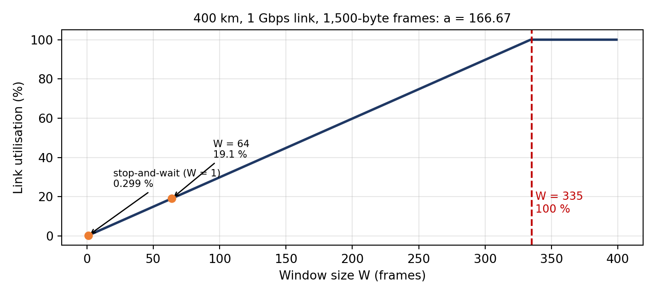
Figure 3: Utilisation of the head-office link against window size
4. Go-Back-N or Selective Repeat after one loss
Selective Repeat resends fewer frames: only the lost frame (1), while Go-Back-N resends the lost frame and everything sent after it, up to 335 frames. The cost is on the receiver: it must keep a buffer for out-of-order frames (up to 335 × 1,500 B = 502.5 kB), reorder them before delivery, and use individual acknowledgements/NAKs and a more complex implementation. The Go-Back-N receiver only needs a window of 1 (no buffer) but wastes up to 502.5 kB of retransmission per loss. On a link with a=166.7 and a small loss rate, Selective Repeat (in practice TCP with SACK) is the better choice.
5. How HDLC and PPP mark frame boundaries
HDLC and PPP frames start and end with the flag byte 01111110 (0x7E). To stop the pattern from appearing inside the data, HDLC on synchronous links uses bit stuffing (the sender inserts a 0 after every five consecutive 1s; the receiver removes it), and PPP on byte-oriented links uses byte stuffing (a 0x7D escape byte, then the byte XOR 0x20). The frame also ends with an FCS for error detection.
6. Complete the Code – Task09/window.py
"""Link utilisation of stop-and-wait and sliding-window protocols on different links."""

def utilisation(frame_bits, rate_bps, distance_m, window, speed=2e8):
tx = frame_bits / rate_bps # transmission time
prop = distance_m / speed # propagation time
# TODO 1 (completed): a = prop / tx. Utilisation is window / (1 + 2a), but never more
than 1.
a = prop / tx
u = min(1.0, window / (1 + 2 * a))
return u, a

links = [("Campus LAN, 200 m, 1 Gbps", 1e9, 200),
("City fibre, 50 km, 1 Gbps", 1e9, 50_000),
("Satellite, 36,000 km, 10 Mbps", 10e6, 36_000_000)]
for name, rate, dist in links:
u1, a = utilisation(12_000, rate, dist, 1)
u7, _ = utilisation(12_000, rate, dist, 7)
u127, _ = utilisation(12_000, rate, dist, 127)
print(f"{name:<31} a = {a:7.2f} stop-and-wait {u1:6.1%} "
f"W=7 {u7:6.1%} W=127 {u127:6.1%}")
Output :
Campus LAN, 200 m, 1 Gbps a = 0.08 stop-and-wait 85.7% W=7 100.0% W=127 100.0%
City fibre, 50 km, 1 Gbps a = 20.83 stop-and-wait 2.3% W=7 16.4% W=127 100.0%
Satellite, 36,000 km, 10 Mbps a = 150.00 stop-and-wait 0.3% W=7 2.3% W=127 42.2%
Smallest window for 100 % on the satellite link: a = 150, so W ≥ 1 + 2a = 301 frames (Go-Back-N 9 bits, Selective Repeat 10 bits). The program's W = 127 gives 42.2 % because 127 ÷ 301 = 0.422.
Program: Task09/window_extra.py – output
head-office link: tx = 12.0 us, prop = 2.00 ms, a = 166.67
stop-and-wait utilisation = 1/(1+2a) = 0.00299 = 0.299 % -> 2.99 Mbps of 1000 Mbps
smallest window for full use: W >= 1 + 2a = 334.33 -> 335 frames (bandwidth-delay product 502.5 kB)
sequence-number bits for W = 335: Go-Back-N 9 bits (2^9 = 512), Selective Repeat 10 bits (2^10 = 1024)
after one loss: Selective Repeat resends 1 frame, Go-Back-N resends up to 335 frames; SR receiver buffer up
to 335 x 1500 B = 502.5 kB
satellite link: a = 150; smallest window for 100 % utilisation = 1 + 2a = 301 -> 301 frames; GBN 9 bits, SR
10 bits
Selective Repeat, window 64: utilisation = 64/334.33 = 19.14 %, throughput = 191.4 Mbps, receiver buffer =
64 x 1500 B = 96,000 B = 93.75 KiB, sequence bits needed = 7
using the measured RTT of 12.6 ms: bandwidth-delay product = 1.575 MB = 1050 frames
7. Alternative: Selective Repeat with window 64
Quantity | Working | Result
Utilisation | 64 ÷ 334.33 | 19.14 %
Throughput | 0.1914 × 1,000 Mbps | 191.4 Mbps
Receiver buffer | 64 × 1,500 B | 96,000 B ≈ 93.75 KiB
Sequence-number bits | 2^(k−1) ≥ 64 | k = 7

Window 64 uses only a fifth of the link (191.4 Mbps against 1,000 Mbps), a saving of 407 kB of buffer compared with window 335. This is acceptable only if the head-office link carries less than about 190 Mbps (for example production data, not CCTV video); with TCP on the measured round-trip time of 12.6 ms, the bandwidth-delay product is 1.575 MB (about 1,050 frames), so the window would have to be even larger to fill the link. Justification: window 335 (or more) with Selective Repeat/SACK for a full 1 Gbps; window 64 as a cheaper choice only if the real demand is below 190 Mbps.
TASK 10 – Find Where the Delay Comes From
Ans:
1. Propagation delay and how much of the measurement it explains
Propagation delay = 400,000 m ÷ 2 × 10⁸ m/s = 2.0 ms one way, 4.0 ms round trip. Traceroute times are round-trip, and the last hop shows about 12.6 ms. The fibre therefore explains 4.0 ÷ 12.6 = about 32 % of the delay. The remaining 8.6 ms is queuing, router processing, serialisation, carrier equipment and the fact that real fibre routes are longer than the straight-line 400 km (a route of 520 km would already need 5.2 ms). The result is reasonable: the path is not broken, and about two thirds of the delay can be improved only by better equipment or routing, not by the speed of light.
2. Hop 3 (38.2 ms) and hop 5 (stars): faults?
- Hop 3, one value of 38.2 ms: the other two replies from the same router are 4.0 and 4.2 ms, and the later hops (hop 4: 11.5–12.1 ms, hop 6: 12.4–12.9 ms) show no such jump. So the data path through the router was not slow. A router answers a traceroute probe (ICMP "Time Exceeded") using its control-plane CPU, which treats it with low priority; one busy moment, or ICMP rate limiting, delays that single reply. Not a fault – an isolated measurement artefact. It is worth watching, but only repeated spikes would suggest an overloaded router.
- Hop 5, only stars: the router did not answer the probes – typically because a firewall or the router's configuration blocks or rate-limits ICMP, or the carrier's core router does not generate Time Exceeded messages. Since hop 6 answers normally (12.6 ms), the probes (and data) pass through hop 5. A real fault would show stars at every later hop and no arrival at the destination. Not a fault.
3. Which hop adds the most delay
Using the middle value of each hop (so the single 38.2 ms is ignored): hop 1: 0.6 ms; hop 2: 3.1 (+2.5); hop 3: 4.2 (+1.1); hop 4: 11.8 (+7.6); hop 6: 12.6 (+0.8). Hop 4 (103.21.8.17) adds the most delay, about 7.6 ms – it is the first public address, which is the long-distance carrier segment where the 4 ms of propagation and the carrier's equipment appear. (If the average of hop 3, 15.5 ms, were used, hop 4 would look faster than hop 3, which is misleading.) Hop 2 (100.64.0.1) is carrier-grade NAT space, which shows the plant reaches the carrier through address translation.
Program: Task10/propagation.py – output
one-way propagation = 2.00 ms, round trip = 4.00 ms
hop average median
1 0.57 0.60 ms
2 3.13 3.10 ms
3 15.47 4.20 ms
4 11.80 11.80 ms
6 12.63 12.60 ms
propagation RTT 4.0 ms explains 32 % of the 12.6 ms measured to hop 6; the other 8.6 ms is queuing,
processing, serialisation and a fibre route longer than 400 km
if the fibre route were 1.3 x 400 km = 520 km: RTT propagation = 5.2 ms

Delay added by each visible hop (using medians, which ignore the single 38.2 ms value):
hop 1: median 0.6 ms, added 0.6 ms
hop 2: median 3.1 ms, added 2.5 ms
hop 3: median 4.2 ms, added 1.1 ms
hop 4: median 11.8 ms, added 7.6 ms
hop 6: median 12.6 ms, added 0.8 ms
4. My own traceroute, ping and Wireshark capture
This evidence must come from a real connection on my own computer. The commands and the steps are in Task10/measure_commands.txt (ping -n 20 / ping -c 20, tracert / traceroute, and a Wireshark capture with the filter host <server>). The screenshots are to be inserted below, with the following headers marked:
Layer | Header to mark in the Wireshark screenshot | Fields to note
2 – Data link | Ethernet II | Destination and source MAC, EtherType 0x0800
3 – Network | Internet Protocol version 4 | Source and destination IP, TTL, protocol
4 – Transport | Transmission Control Protocol (or UDP / ICMP) | Source and destination port, flags, sequence and acknowledgement numbers
7 – Application | HTTP / DNS / TLS (whatever the connection used) | Application message

5. Alternative: SNMP / NetFlow monitoring against occasional tests
Problem in the traceroute | SNMP counters and NetFlow (continuous) | Occasional ping / traceroute
Hop 3 single 38.2 ms reply (control-plane CPU spike) | SNMP CPU and queue counters, polled every 1–5 min, would show a spike only if it lasts; a single one-second event is averaged out. Detected: sometimes, after minutes. | Seen immediately in that run, but only if the test happens at that moment; a single run cannot tell a fault from an artefact.
Hop 5 stars (ICMP not answered) | Not detected, and not a problem: NetFlow shows normal traffic to 10.200.0.10 passing through, which confirms it is not a fault. | Shown as stars; needs interpretation (hop 6 answers).
A real fault: link errors, congestion, rising delay | SNMP interface errors, discards and utilisation, and NetFlow top talkers, detect it within one polling interval (about 1–5 min) and keep history for trends and alarms. | Detects it only if someone runs the test during the fault; intermittent faults are missed; no history.
Where the 7.6 ms of hop 4 is spent | Not shown (flow records and counters give volume, not per-hop delay). | Shows it directly per hop.

Conclusion: use both. Continuous monitoring gives early, historical and automatic detection of congestion and errors; ping and traceroute locate the delay along the path when a problem is reported.
TASK 11 – Defend the Network Design
Ans:
1. Recommended design
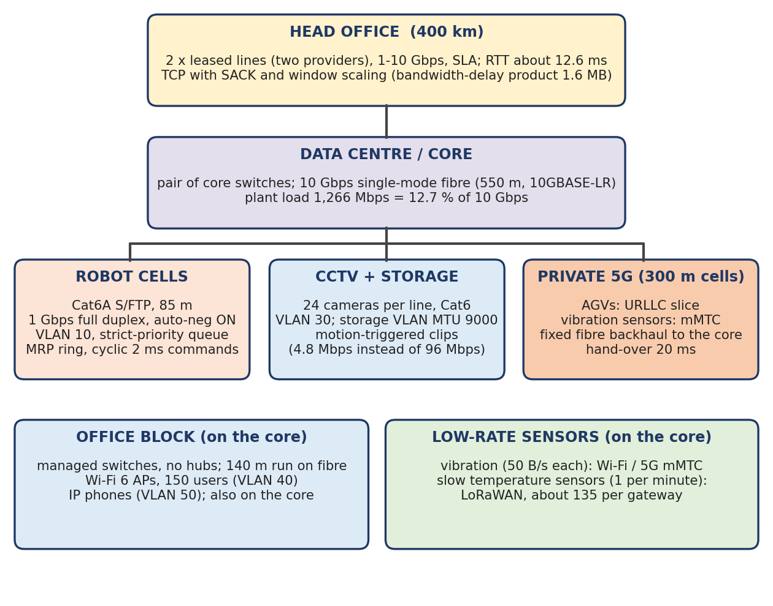
Figure 4: Recommended network design for the plant
Area | Medium | Wireless | Ethernet settings | Numbers that justify it
Robot cells (40 per line) | Cat6A S/FTP, 85 m (fibre if noise tests fail) | None (no Wi-Fi) | 1 Gbps full duplex, auto-negotiation on; own VLAN, strict-priority queue; MRP ring | Capacity at 15 dB falls from 3,322 to 1,257 Mbps (−62 %) (Task 4); Wi-Fi cannot guarantee 10 ms; duplex mismatch gave 412 late collisions (Task 6)
Shop floor to data centre | Single-mode fibre, 550 m, 10GBASE-LR | – | 10 Gbps, pair of core switches | Plant 1,265.92 Mbps = 126.6 % of 1 Gbps, but 12.7 % of 10 Gbps (Task 1); copper limit 100 m (Task 4)
Office block | 140 m on multimode fibre; managed switches instead of hubs | Wi-Fi 6 (150 users) | Full duplex; separate VLANs for PCs and IP phones | 30 Mbps office load per line; Wi-Fi 6 capacity 1,329 Mbps at 25 dB; collisions 17 → 41 domains with no collisions (Task 2)
CCTV | Cat6 to storage VLAN | – | Jumbo frames (MTU 9000) on the storage VLAN only | Motion-triggered clips cut 96 → 4.8 Mbps per line (Task 1); efficiency 96.2 % → 99.4 % (Task 6)
AGVs / moving equipment | Fibre backhaul to cells | Private 5G (URLLC) | – | Hand-overs 4 × 20 ms = 0.08 s against Wi-Fi 40 × 150 ms = 6.0 s (Task 5)
Sensors | – | Vibration: Wi-Fi / 5G mMTC; slow temperature: LoRaWAN | – | 600 × 50 B/s = 240 kbps against a 5 kbps LoRa gateway (Task 5)
Plant to head office | Two leased lines (different carriers), SLA | – | PPP/HDLC or Ethernet WAN framing; TCP with SACK and window scaling | a = 166.7; stop-and-wait gives 2.99 Mbps; window 335 (Task 9); measured RTT 12.6 ms (Task 10)

2. Error control and flow control for each link, with justification
Link | Error control | Flow control | Calculation that justifies it
Robot cell Ethernet | CRC-32 FCS on every frame; bad frames discarded; the next cyclic command (every 2 ms) replaces a lost one | None needed; rate is fixed and tiny (0.8 Mbps per robot); strict priority protects delay | CRC with r check bits detects all bursts ≤ r (Task 7); 58 B overhead on a 12 B command = 82.9 % (Task 3) so keep commands small; retransmitting after a 40 ms timer is useless for a 10 ms deadline
Wireless sensor link | FEC (Hamming-type) – not ARQ | Fixed reporting rate | At BER 10⁻³, FEC delays 0.02 % of readings by 40 ms against 1.59 % for ARQ (Task 8); 5 check bits for 16 data bits (31.25 %)
Backbone and office (fibre/Ethernet) | CRC-32; TCP retransmission above | TCP window; no 802.3x pause (it blocks other queues) | Very low error rate on fibre, so ARQ is cheap; ordinary TCP is enough
Head-office WAN (400 km) | CRC-32 (PPP/HDLC or Ethernet FCS); Selective Repeat (TCP SACK) | Sliding window, W ≥ 335 frames (≈ 502 kB; ≈ 1.6 MB using the measured RTT) | a = 166.67; stop-and-wait 0.299 %; SR needs 10 sequence bits and resends 1 frame, Go-Back-N up to 335 (Task 9)

3. The two biggest risks that remain
- Risk 1 – gaps longer than the 10 ms deadline. MRP ring recovery (about 200 ms), a 5G hand-over (20 ms) and a leased-line failure are all longer than 10 ms. A robot or AGV would miss 100, 2 and many commands respectively. *Reduction:* local safe-stop on the machine, HSR/PRP (zero recovery) on the critical ring, dual-radio AGVs (Task 12) and two WAN lines.
- Risk 2 – electrical noise and the head-office dependency. Near the welders the SNR is only 15 dB (capacity −62 %); if shielding or earthing fails, errors and retransmissions rise. The WAN has a 12.6 ms round trip, of which 4 ms is physical and cannot be reduced, and one carrier failure isolates the plant. *Reduction:* bonded shielded cable or fibre in the cell, regular noise tests, and a second carrier and local operation of the plant when the WAN is down.
4. Does the design still work for five plants?
Yes, by repetition. Each plant keeps its own design: 1,265.92 Mbps is 12.7 % of its 10 Gbps backbone, and the heavy traffic (CCTV 768 Mbps per plant) stays inside the plant. Five plants have about 5 × 1,266 = 6,330 Mbps of internal traffic if all were sent to the head office, which would exceed a 1 Gbps line five times over; so only production and ERP data (not video) is sent, each plant with its own two leased lines, and the head office has a 10 Gbps core. Addressing and broadcast domains are kept small with VLANs (2 broadcast domains in the office design, Task 2). The window calculation is per link (335 frames), so it does not change with the number of plants. The head-office core must be 10 Gbps or more and monitored with SNMP/NetFlow (Task 10).
5. Alternative: the whole plant on private 5G
Using the Task 1 plant figures (8 lines; traffic in Mbps):
Traffic | Plant load | 5G or cable? | Reason
AGVs (Task 12) and other mobile equipment | 12 Mbps control + 200 Mbps video | 5G (URLLC / eMBB) | Mobility: 0.08 s unreachable against 6.0 s on Wi-Fi.
Wireless sensors | 8 × 0.24 = 1.92 Mbps | 5G (mMTC) | Tiny load, many devices, no cabling.
Motion-triggered camera clips, temporary cameras | 8 × 4.8 = 38.4 Mbps | 5G possible | Small and bursty.
Fixed robot controllers | 8 × 32 = 256 Mbps (330 with headers) | Cable | Deterministic 10 ms; cable is cheaper than reserving radio capacity; 5G hand-over/uplink variation is not needed for fixed machines.
Continuous CCTV | 8 × 96 = 768 Mbps | Cable | A private 5G cell has limited uplink capacity (assume about 300 Mbps; actual value from the vendor), so 768 Mbps would need several cells and starve the control traffic.
Office and ERP | 8 × 30 = 240 Mbps | Cable / Wi-Fi 6 | Large, steady and delay-tolerant; wired is cheapest.
Backbone and head-office link | 1,265.92 Mbps in total | Cable (fibre) | 5G is an access network, not a backbone; the 400 km link is a carrier line anyway.

Split: 5G carries the moving and wireless-sensor traffic (about 214 Mbps of the 1,478 Mbps with AGVs, around 14 %); the 768 Mbps of continuous video, 256 Mbps of robot control, the office and the whole backbone stay on cable. A plant on 5G alone is possible only if CCTV is reduced to motion-triggered clips, and still leaves the fixed robots better served by cable.
Program: Task11/summary_numbers.py – output (numbers quoted from Tasks 1–10)
Task 1 : line 158.24 Mbps, plant 1,265.92 Mbps (126.6 % of 1 Gbps); motion-triggered CCTV: plant 536.32 Mbps
(53.6 %)
Task 2 : collision domains 17 -> 41 after replacing hubs, broadcast domains 2
Task 3 : 58 B headers on a 12 B command = 82.86 % overhead; 3.98 % for a 1,400 B packet; TTL 64 -> 61 = 3
routers
Task 4 : Shannon 3,321.96 Mbps at 40 dB vs 1,256.95 Mbps at 15 dB (-62.2 %); Wi-Fi 6 at 15 dB 804.45 Mbps
Task 5 : Wi-Fi 40 hand-overs x 150 ms = 6.0 s per trip; 5G 4 x 20 ms = 0.08 s; LoRa demand 240 kbps vs 5
kbps
Task 7 : CRC-3 detects every burst <= 3 bits; misses the pattern 1011; internet checksum 7A8C
Task 8 : Hamming 5 check bits for 16 bits (31.25 %); FEC delays 0.02 % of readings by 40 ms, ARQ 1.59 %
Task 9 : a = 166.67, stop-and-wait 0.299 % = 2.99 Mbps; window 335; GBN 9 bits, SR 10 bits; SR window 64 =
191.4 Mbps
Task 10: propagation RTT 4.0 ms of the 12.6 ms measured; hop 4 adds 7.6 ms
TASK 12 – Re-evaluate and Adapt the Design
Ans:
Assumed AGV traffic (not given): each AGV receives a 200 B command every 10 ms, sends a 100 B status every 10 ms, and carries one 4 Mbps camera. Overall decision: MODIFY – keep the wired parts, replace the wireless part for moving equipment.
A. Impact analysis (2 marks)
Item | Affected? | Impact
Media | Yes | 5G cells need a fibre (or Cat6A with PoE) backhaul to the core; the backbone must grow from a 1 Gbps uplink to 10 Gbps single-mode fibre; robot cells and office cabling are not affected.
Wireless choices | Yes | AGVs move from Wi-Fi to private 5G (URLLC for commands, eMBB for cameras); Wi-Fi 6 stays for the office; vibration sensors may use 5G mMTC.
Error-control settings | Yes | AGV links use the radio's FEC (LDPC/polar) with fast HARQ and packet duplication, not retransmission after 40 ms; cyclic commands replace lost ones; wired links keep CRC-32; WAN keeps SACK.
Ethernet settings | Partly | Auto-negotiation on, QoS priority extended to the 5G backhaul ports; jumbo frames stay on the storage VLAN.

Table: traffic of the plant with 50 AGVs added
Item | Calculation | Traffic
AGV commands | 50 × 200 B × 8 ÷ 10 ms | 8.0 Mbps
AGV status | 50 × 100 B × 8 ÷ 10 ms | 4.0 Mbps
AGV cameras | 50 × 4 Mbps | 200.0 Mbps
AGV total |  | 212.0 Mbps
Plant before (Task 1) | 8 × 158.24 | 1,265.92 Mbps
Plant with AGVs | 1,265.92 + 212.0 | 1,477.92 Mbps (+16.7 %) = 147.8 % of 1 Gbps; 14.8 % of 10 Gbps
With motion-triggered CCTV (Task 1 alternative) | 536.32 + 212.0 | 748.32 Mbps

The part that needs the strict 10 ms treatment is small (12 Mbps of commands and status); the 200 Mbps of AGV video can be processed on the AGV, or carried on the eMBB slice, so that it cannot interfere.
B. Test of the original design (2 marks)
Original wireless design: Wi-Fi 6 with 30 m access points and a 150 ms hand-over (Task 5); 50 AGVs, 1.2 km route, 2 m/s, trip 600 s, one command deadline every 10 ms.
Per trip | Wi-Fi, 150 ms | Wi-Fi 6 + 802.11r (50 ms, assumed) | Private 5G, 20 ms (single connection) | Private 5G, dual radio / duplication
Hand-overs per AGV | 40 | 40 | 4 | 4
Unreachable time per AGV | 6.0 s | 2.0 s | 0.08 s | ≈ 0 s (gap masked)
Missed 10 ms commands per AGV | 600 | 200 | 8 | 0
Hand-overs by all 50 AGVs | 2,000 (one every 0.3 s) | 2,000 | 200 (one every 3 s) | 200
Missed commands, all 50 AGVs | 30,000 | 10,000 | 400 | 0

Result: the original design cannot serve 50 moving AGVs under "never miss a command". On Wi-Fi each AGV is unreachable for 6.0 s per trip and misses 600 deadlines; across 50 AGVs a hand-over occurs every 0.3 s, and the channel is also shared with 1,500 other devices. Even with fast roaming, 10,000 commands are missed. Private 5G reduces the gap to 0.08 s per trip, but a single 20 ms hand-over still misses 2 commands, 8 per trip, 400 for the fleet – so 5G alone is not enough; the adapted design must also mask the hand-over.
C. Adaptation or redesign (2 marks)
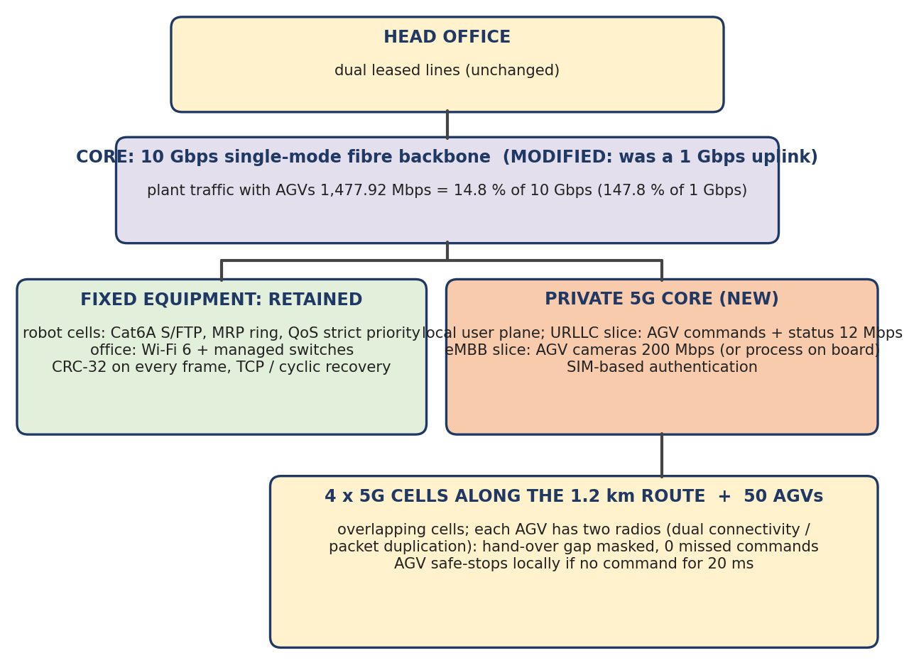
Figure 5: Revised design with private 5G and 50 AGVs
Part of the design | Decision | Revised solution
Fixed robot cells (Cat6A S/FTP, MRP ring, QoS) | RETAIN | Wired control is deterministic; AGVs do not change it.
Office (Wi-Fi 6, managed switches, fibre 140 m) | RETAIN | Unaffected by the 5G network.
Backbone | MODIFY | 10 Gbps single-mode fibre; 1,477.92 Mbps is 14.8 % of it (it was 147.8 % of the 1 Gbps uplink).
Moving equipment | REDESIGN | Private 5G: URLLC slice for AGV commands and status (12 Mbps), eMBB for cameras or on-board processing; 4 cells of 300 m along the 1.2 km route with overlapping coverage; each AGV with two radios (dual connectivity / packet duplication) so one cell is always available during a hand-over; on-board safe-stop if no command arrives for 20 ms; SIM-based authentication.
Error control for AGVs | MODIFY | FEC and fast HARQ in the radio; cyclic commands; no ARQ with a 40 ms timer.

D. Evidence-based defence (2 marks)
Measure | Original (Wi-Fi) | Revised (private 5G, dual radio)
Hand-overs per AGV per trip | 40 | 4
AGV unreachable per trip | 6.0 s (1 %) | 0.08 s without duplication; ≈ 0 with duplication
Missed 10 ms commands, 50 AGVs per trip | 30,000 | 400 without duplication; 0 with duplication
Backbone load | 147.8 % of 1 Gbps (overloaded) | 14.8 % of 10 Gbps

Why MODIFY and not RETAIN or full REDESIGN: RETAIN is rejected because 30,000 missed commands per trip violates the "never miss" requirement and the 1 Gbps uplink is at 147.8 %. A full REDESIGN of everything is not needed because the fixed robots (256 Mbps) and the office (240 Mbps) are served well by cable, which is cheaper and more deterministic; the changed requirement affects only moving equipment and the backbone.
Trade-offs: (1) Cost – private 5G radios and core, a spectrum or operator arrangement, and two radios per AGV cost more than Wi-Fi access points; justified because Wi-Fi misses 75 times more command time. (2) Complexity – two radio technologies, SIM management and 5G skills are needed, and QoS must be set up end to end. (3) Remaining risk – the 20 ms hand-over is still twice the deadline if duplication fails, so the safe-stop on the AGV is mandatory; the 5G cells and core are a single point of failure and need redundancy; the 10 Gbps backbone and the 802.3 ring still need monitoring (Task 10). (4) Benefit – the original wired design, the switched, collision-free LAN of Task 2, error control and window sizes are kept, so most of the earlier work is reused.
Program: Task12/impact.py – output
AGV commands 8.0 Mbps, AGV status 4.0 Mbps, AGV cameras 200.0 Mbps -> AGV total 212.0 Mbps
plant traffic: 1265.92 -> 1477.92 Mbps (+16.7 %) = 147.8 % of a 1 Gbps uplink; on a 10 Gbps backbone 14.8 %
traffic that must be on the 5G URLLC slice (commands + status) = 12.0 Mbps; cameras (eMBB, or processed on the AGV) =
200.0 Mbps
with motion-triggered CCTV (Task 1 alternative) the plant needs 536.3 Mbps + AGV 212.0 = 748.3 Mbps

Test of the ORIGINAL design (Wi-Fi) for 50 AGVs on the 1.2 km, 2 m/s route (trip 600 s):
Wi-Fi, 150 ms hand-over hand-overs/AGV 40, unreachable/AGV 6.000 s,
missed 10 ms commands/AGV 600.0, all 50 AGVs: 2000 hand-overs, 30000 missed commands per trip, one
hand-over every 0.30 s
Wi-Fi 6 + 802.11r, assumed 50 ms hand-overs/AGV 40, unreachable/AGV 2.000 s,
missed 10 ms commands/AGV 200.0, all 50 AGVs: 2000 hand-overs, 10000 missed commands per trip, one
hand-over every 0.30 s
Private 5G, 20 ms hand-over (single connection) hand-overs/AGV 4, unreachable/AGV 0.080 s,
missed 10 ms commands/AGV 8.0, all 50 AGVs: 200 hand-overs, 400 missed commands per trip, one
hand-over every 3.00 s
Private 5G, dual-connection / packet duplication (assumed 0 ms gap) hand-overs/AGV 4, unreachable/AGV 0.000 s,
missed 10 ms commands/AGV 0.0, all 50 AGVs: 200 hand-overs, 0 missed commands per trip, one
hand-over every 3.00 s

